The History of Graffiti
Modern day graffiti can be traced back to Philadelphia during the late 60's. During this period it was mostly used by political activists or gangs marking their territory.

During the early 70's the writer TAKI 183 took it to another level by covering much of New York City with his tag. The New York Times did an article on Taki which exposed tagging to the public. Taki was not the first writer, but is legendary for bringing so much attention to it.

Tagging became a competition between the boroughs of NYC to see who could cover more area with their tags. The letters evolved into block and bubble letters which formed the basis for the many styles employed today. The art form was booming and took shape in the subways of NYC. They are still considered by many to be the ultimate canvas for a true writer.

Whereas during the 70's graffiti was flourishing, the 80's proved to be a very trying time for the subway writers because the Metropolitan Transit Authority began to focus on stopping it. A few die-hard artists refused to be beaten and kept the art form alive during this period. The emergence of hip-hop in main-stream culture during the 80's exposed graffiti to the world and it began showing up everywhere. This exposure led to the popularity and extensive graffiti writing of today.

There are many different styles of graffiti writing. Here are a few examples and short descriptions of some of the most commonly seen.
 | Tag Style  Tag style is the most basic and quickest form of graffiti writing. It is usually a representation of the artist’s name and is used as a way to gain recognition by being seen in a lot of places and as a signature for larger pieces.
Throw-Up  This style is another quick method of graffiti writing. It is done by making a layer of paint in one color and a quick outline of the letters in another. | 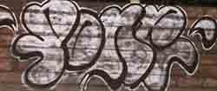
 | Blockbuster  Blockbuster letters are evenly spaced and not too difficult to read. They are just what the name implies, block letters. This style is often done on large areas such as whole train cars.
Wild Style  This style is much more complex than any of the previously mentioned. The letters are very blended and highly decorated. This type of writing can be very difficult to decipher. | 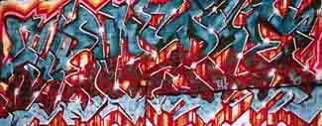
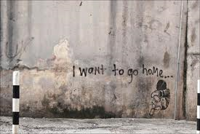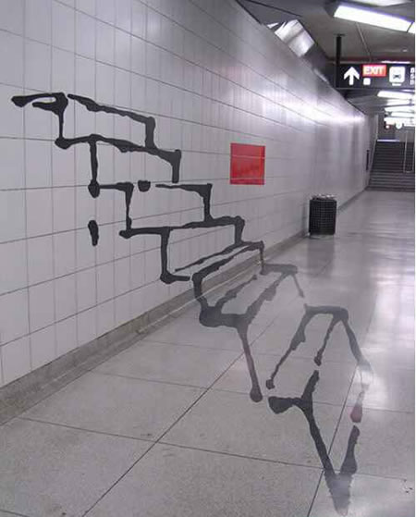 your graffiti here

